Experiment – 8
Question:
Create a Virtual Hard Disk and allocate the storage using virtual box.
Answer:
AIM: To create and allocate a virtual hard disk.
SOFTWARE REQUIRED: Virtual Box, Host OS: Windows
PROCEDURE:
STEP 1: Open VirtualBox
Click Start → Oracle VM VirtualBox
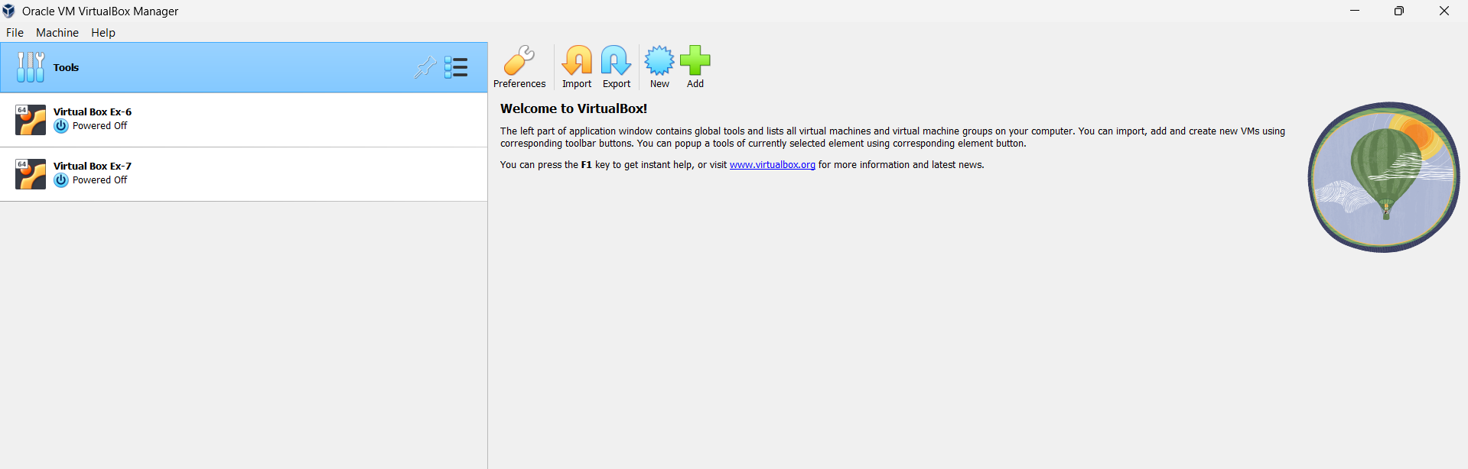

STEP 2: Create New VM
Click New
Name: Virtual Box Ex-8
Type: Linux
Version: Ubuntu (64-bit)
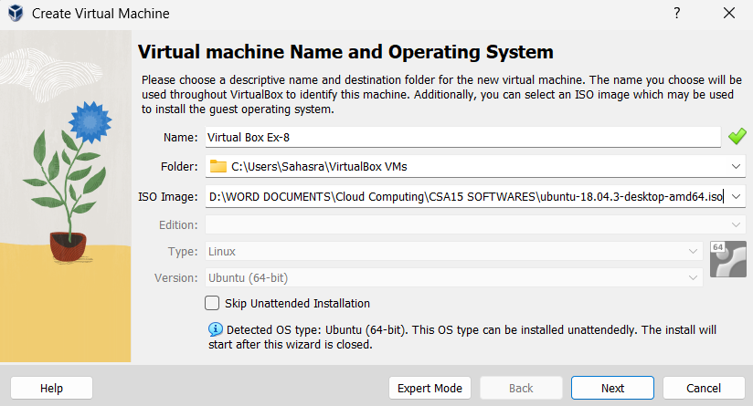
STEP 3: Select ISO File
Click ISO Image
Browse and select Ubuntu ISO
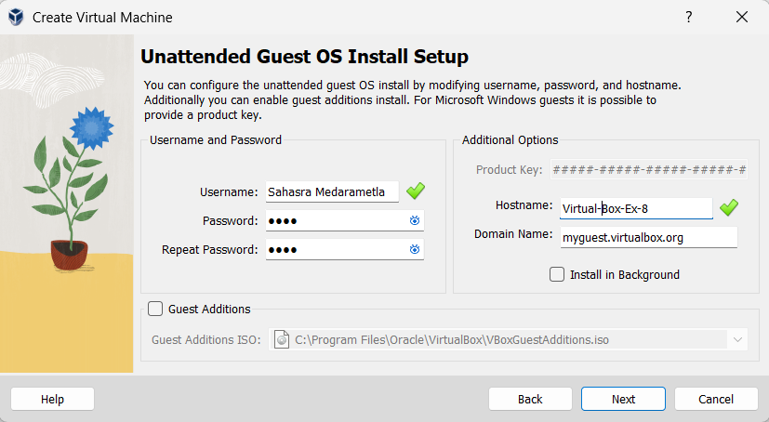
STEP 4: Set CPU = 1
Set Memory = 2048 MB
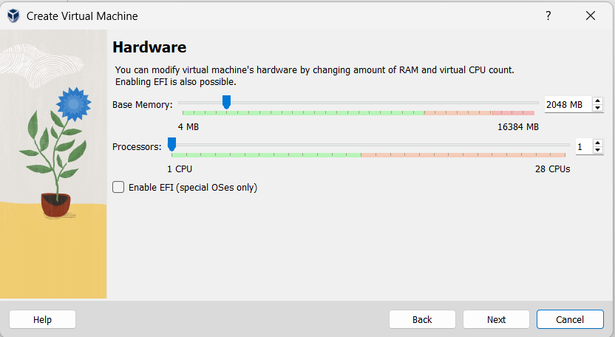
STEP 5: Set Disk Size
Verify disk = 25 GB

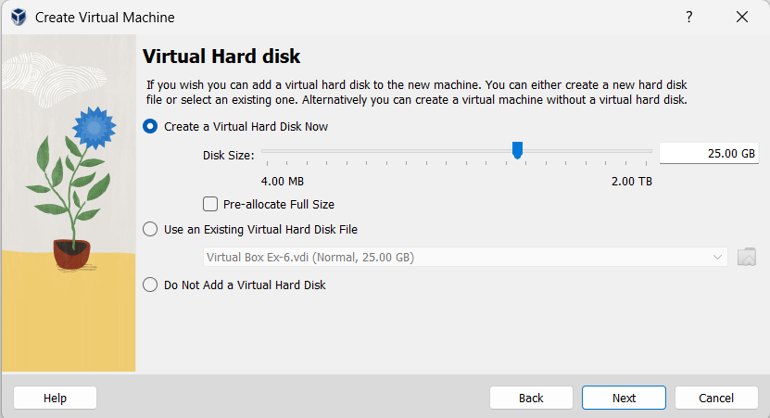

STEP 4: Finish Setup
Click Next → Finish
Click Start to run VM

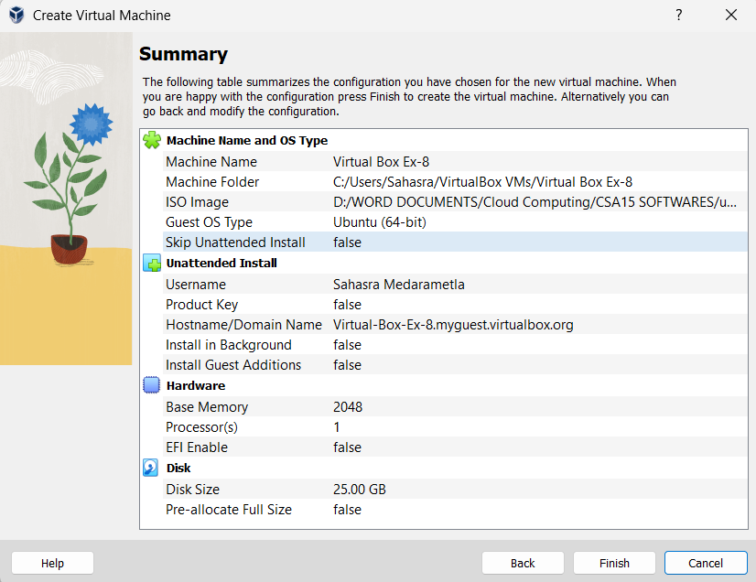

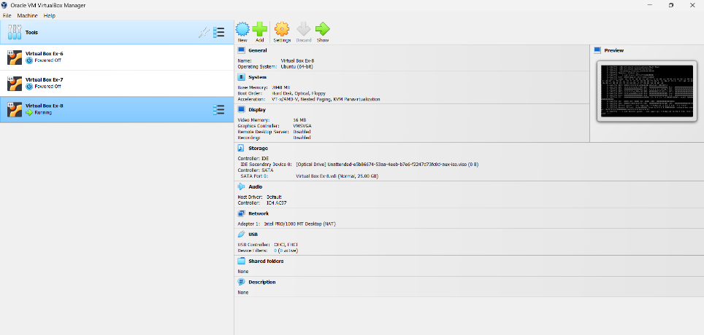

STEP 5: Power OFF VM
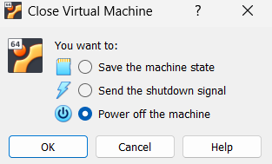
STEP 6: Open Settings
Select VM → Settings → Storage
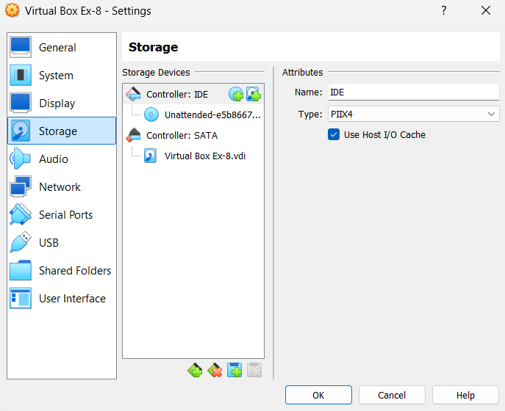
STEP 7: Add Disk
Click Controller SATA → Add Hard Disk icon
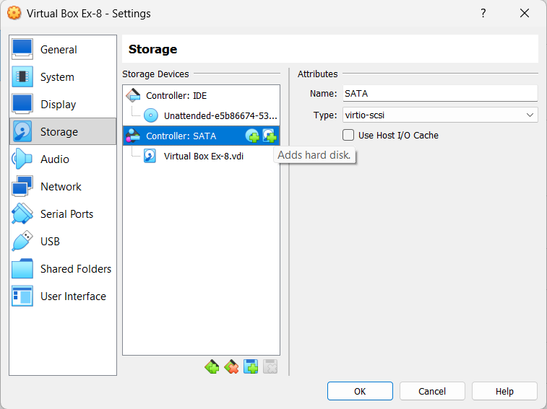
STEP 8: Create New Disk
Choose Create
Disk Type: VDI
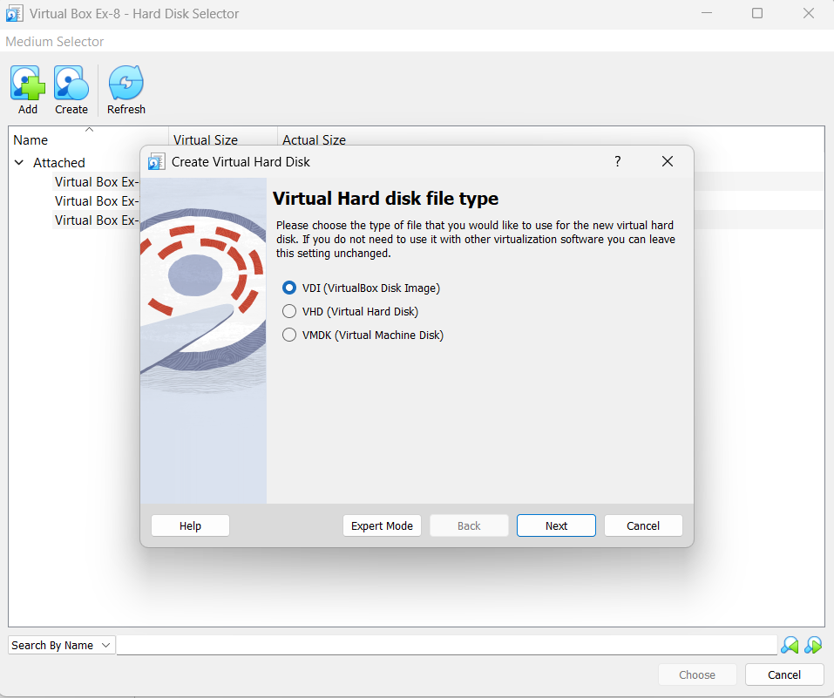
STEP 9: Allocation Type
Select Dynamically Allocated
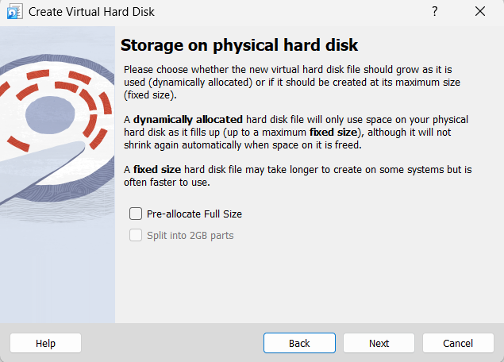
STEP 10: Disk Size
Enter size (Example: 10GB)
Click Create
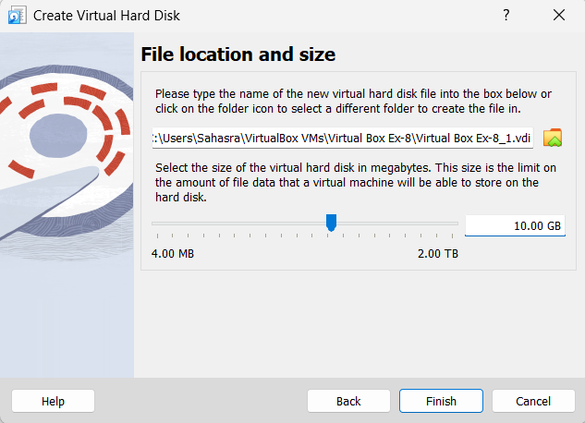
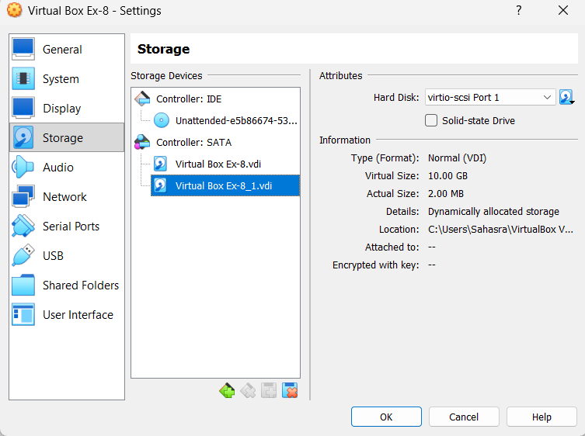

RESULT: Virtual hard disk created successfully.

